**SKY system introduction**

If you server is working, then we can see the first page as the following:

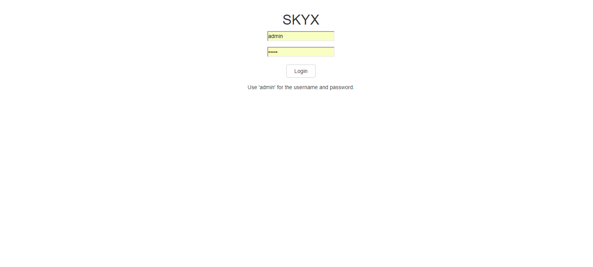

In this page, we need to type user id and password.

In current version, user id is “admin” and password is also “admin”.

If you type user id and password and click “Login”, then we can see second image as the following:

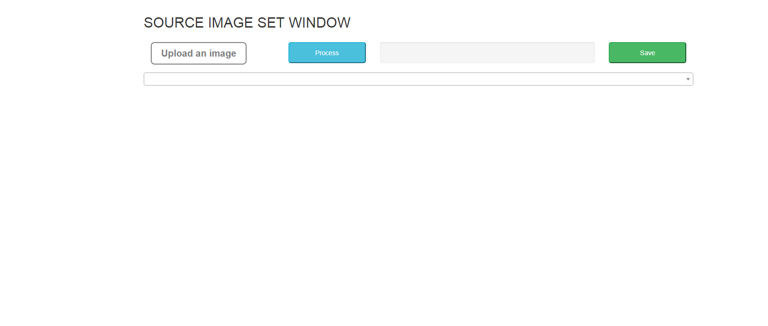

You can see three buttons in this page.

1. Upload an image button

This button is for uploading image.

If you upload image, then uploaded image is saved in special folder of server with unique name.

For generating the unique image name, in the current code, we used encode function.

If you upload image, you can see the following result.

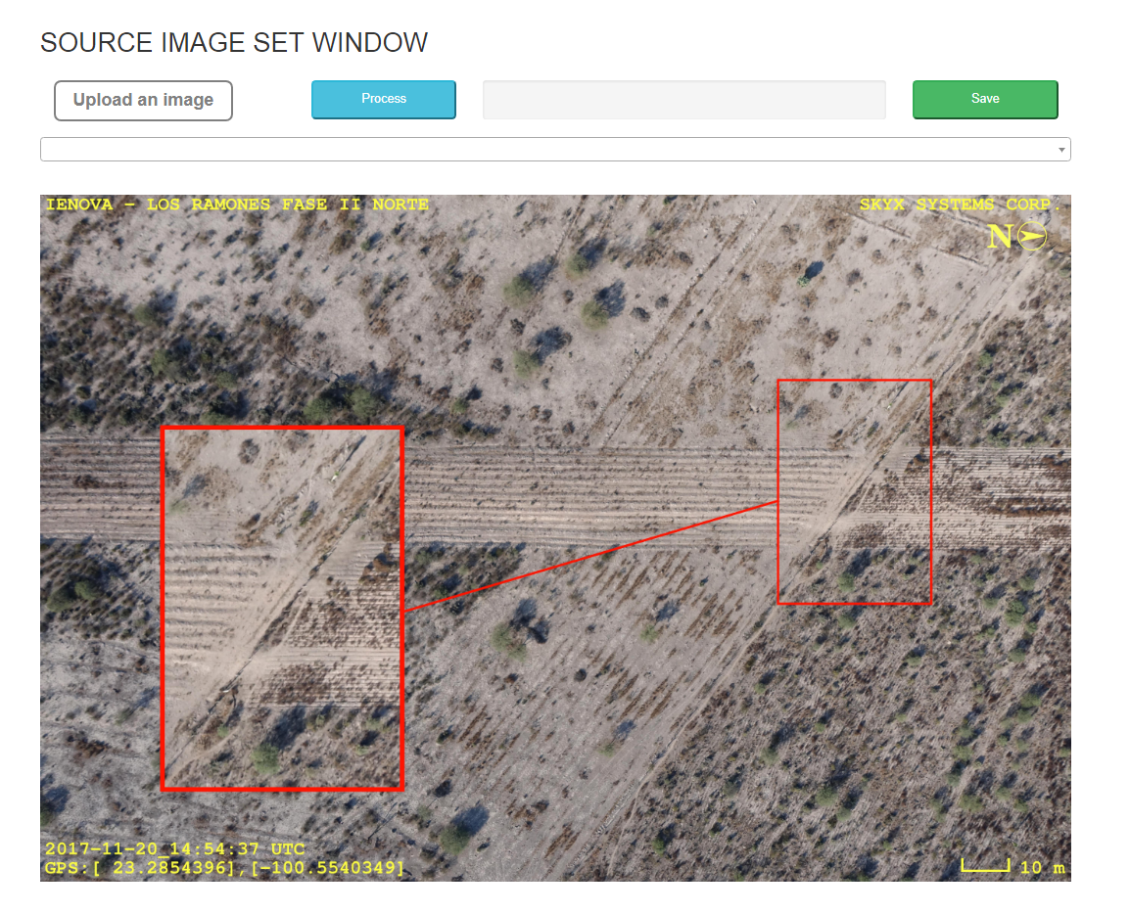

On image, you can drag and drop to detection abnormal part. For example, you can select the abnormal part by using mouse such as the following:

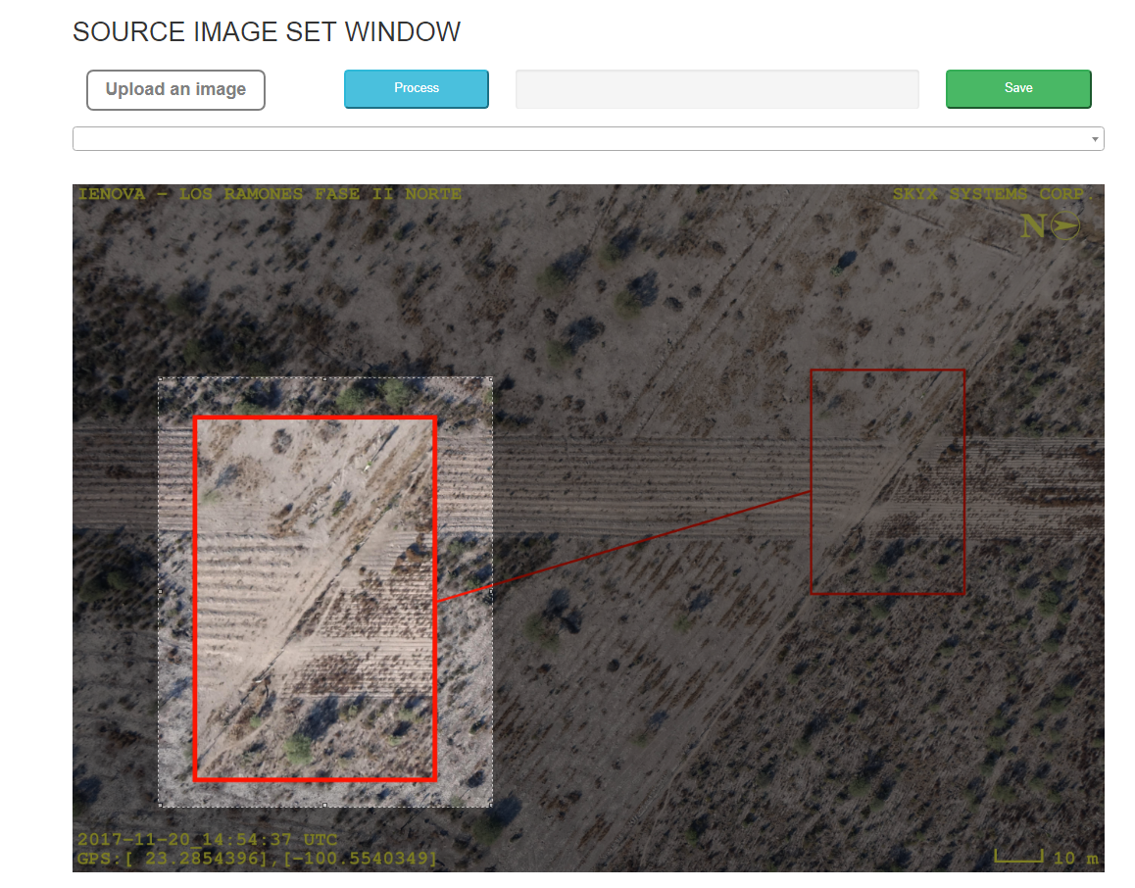

We can click next button, now.

1. Process button.

If we click this button, then we can get cropped image from uploaded image. And the current code finds the similar categories among all categories.

So we can see similar categories in list box. See the following result.

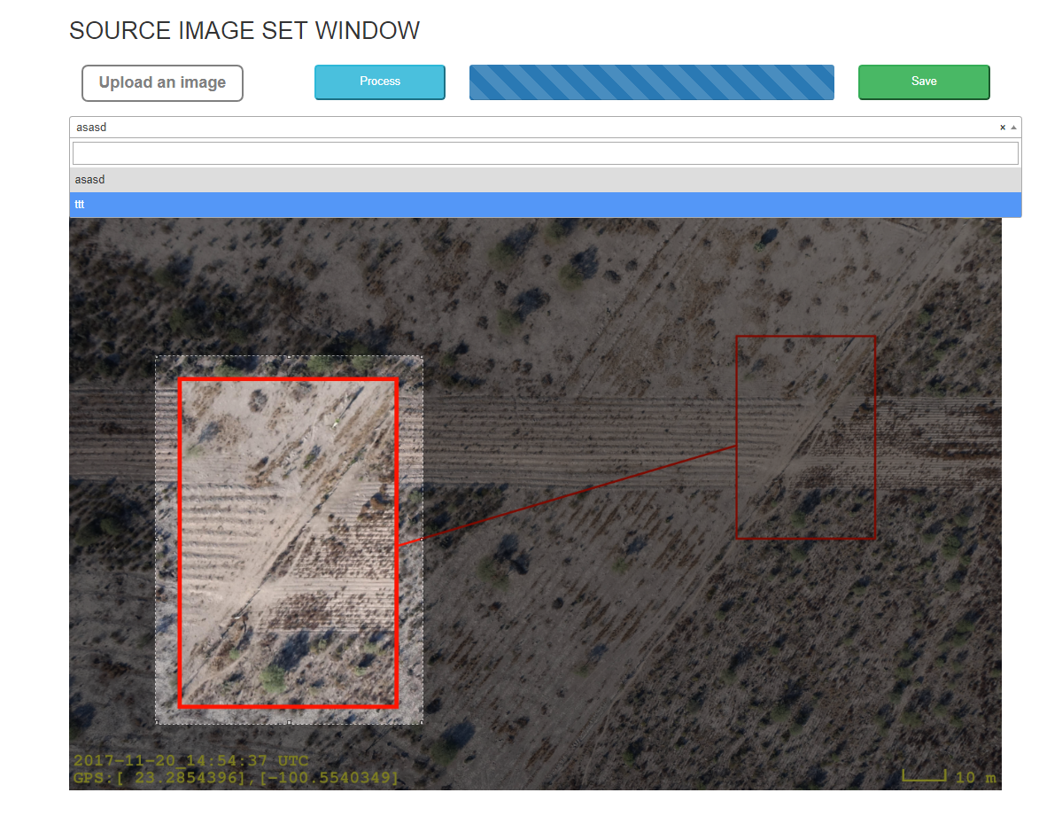

If you want to create new category, then you can type category name in list box.

The following figure shows the adding new category with name “holes”. If you click “Enter”key, then new category name will be added in listbox.

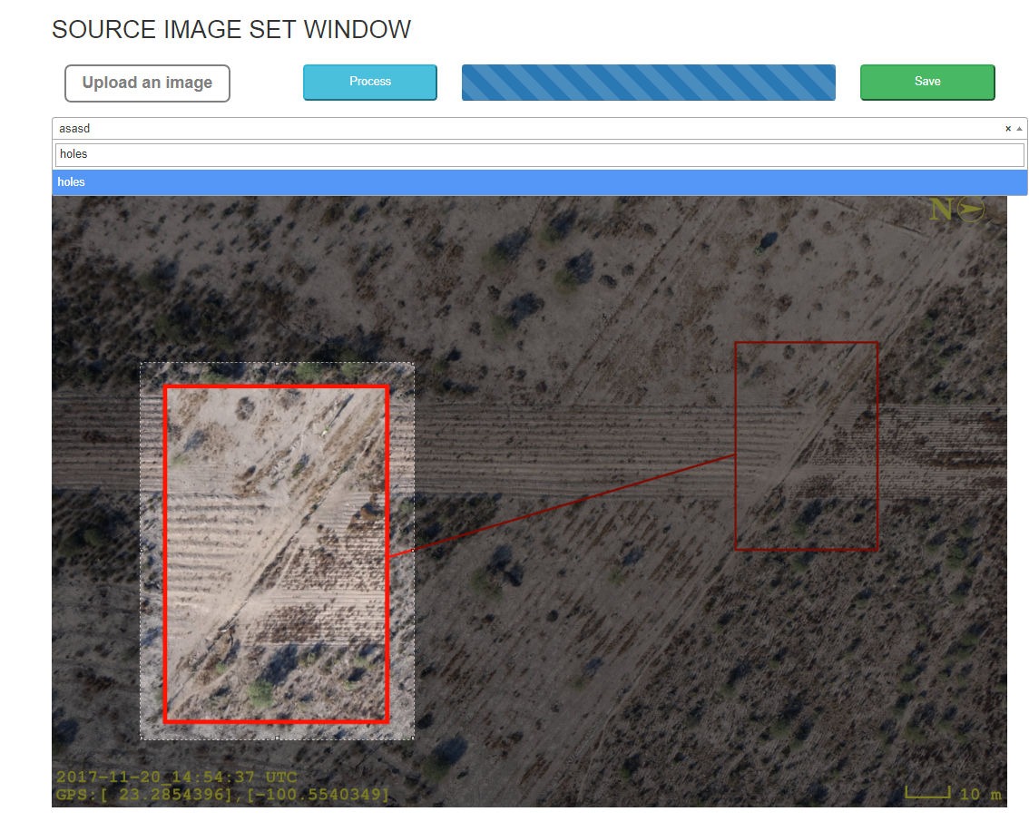

As you can see in the below figure, holes category is added now.

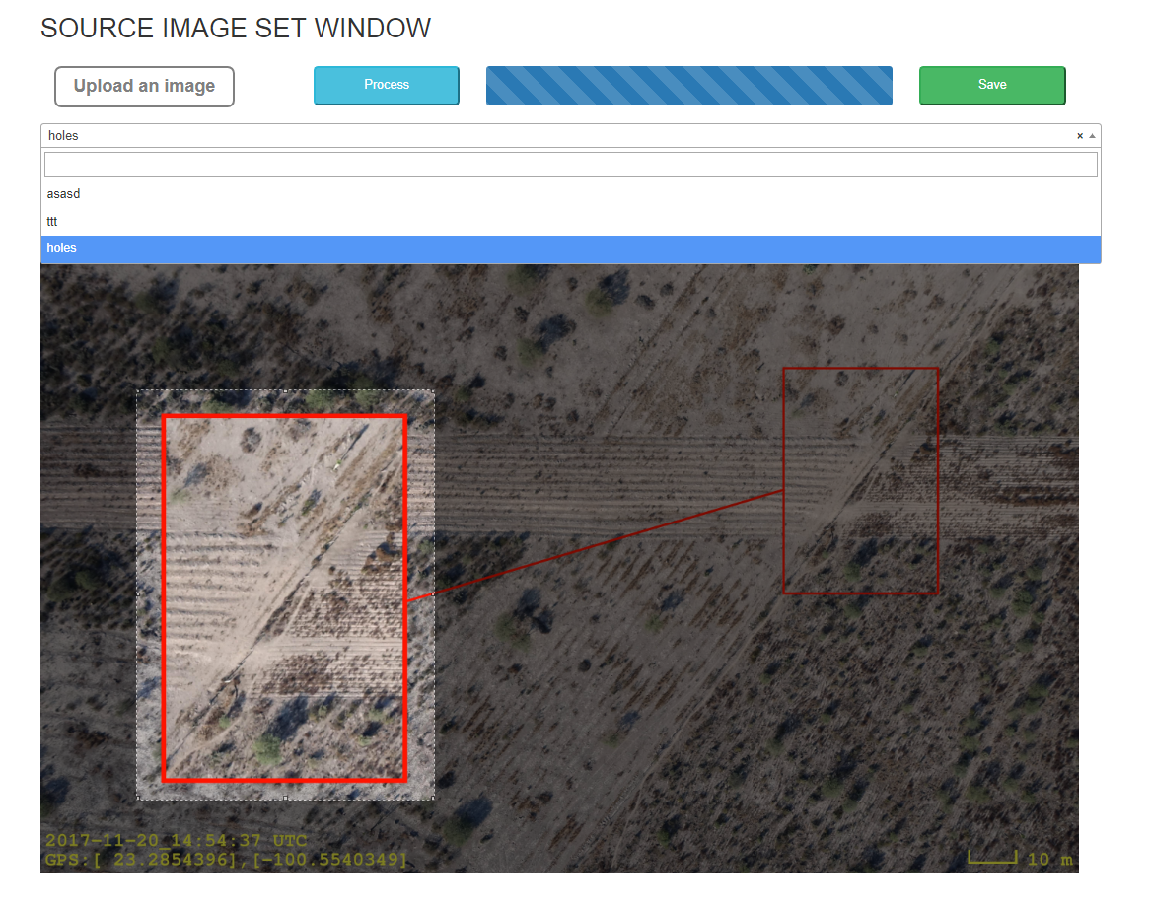

Now we can click “Save” button.

1. “Save” button

If you click save button, then cropped image will be saved in special folder.

For new category, code creates new folder and save it in new folder.

By using this web app, we can get training data. If we get training data, we can get new version of auto abnormal detection and classification.